**IT Employee Management System**

**Step 1: Database Schema Requirements**

**Entities:**

1. **Employee**
2. **Department**
3. **Project**
4. **Skill**
5. **EmployeeSkill** (Many-to-Many)
6. **ProjectAssignment** (Many-to-Many)

**Step 2: SQL Script to Create the Schema**

**Creating Database – IT_Employee**

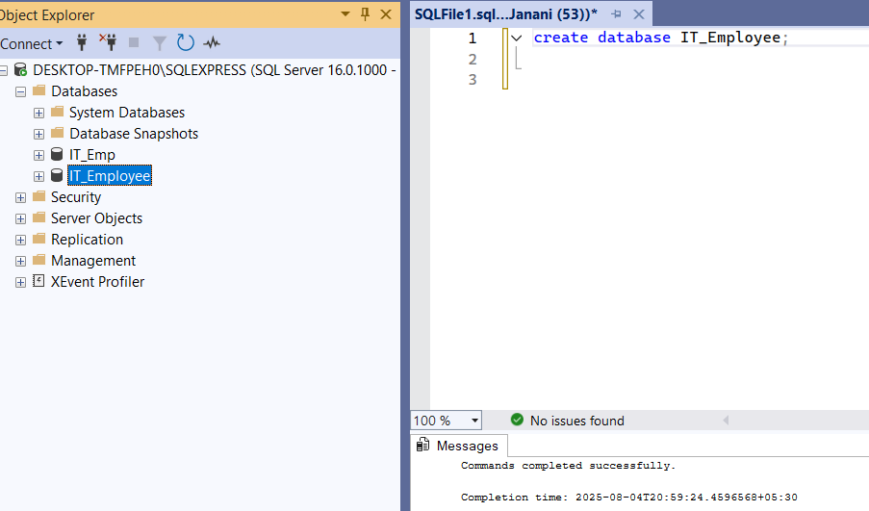

**Department Table:**

**Employee Table:**

**Project Table:**

**Skill Table:**

**Employee Skill Table:**

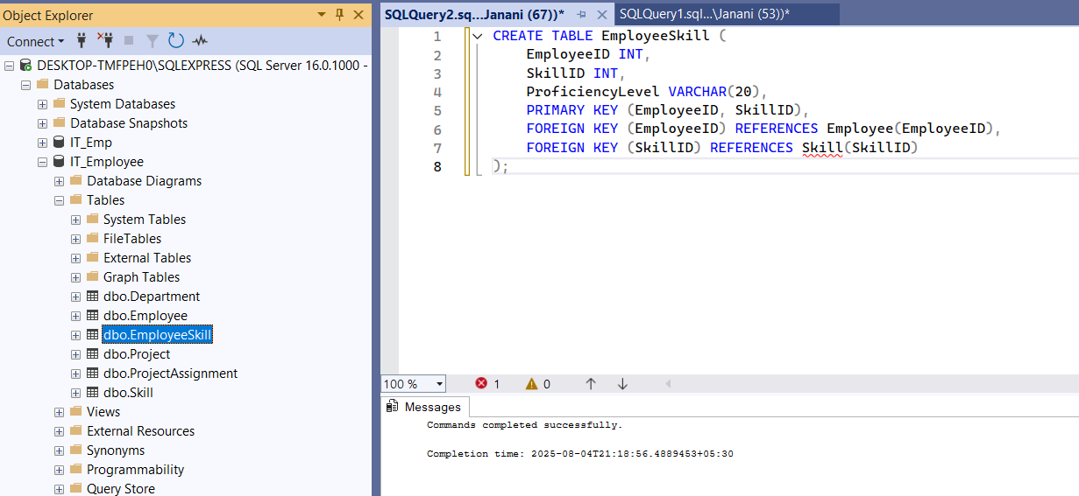

**Project Assignment Table:**

**Step 3: ER Diagram Description**

Here’s how the ER diagram will look:

**Entities and Attributes**

* **Department**
  + DepartmentID (PK)
  + DepartmentName
* **Employee**
  + EmployeeID (PK)
  + FirstName
  + LastName
  + Email
  + Phone
  + HireDate
  + JobTitle
  + DepartmentID (FK)
* **Project**
  + ProjectID (PK)
  + ProjectName
  + StartDate
  + EndDate
* **Skill**
  + SkillID (PK)
  + SkillName
* **EmployeeSkill**
  + EmployeeID (FK)
  + SkillID (FK)
  + ProficiencyLevel
* **ProjectAssignment**
  + EmployeeID (FK)
  + ProjectID (FK)
  + Role
  + AllocationPercentage

**Relationships**

* **Department —< Employee** (One-to-Many)
* **Employee —< EmployeeSkill >— Skill** (Many-to-Many)
* **Employee —< ProjectAssignment >— Project** (Many-to-Many)

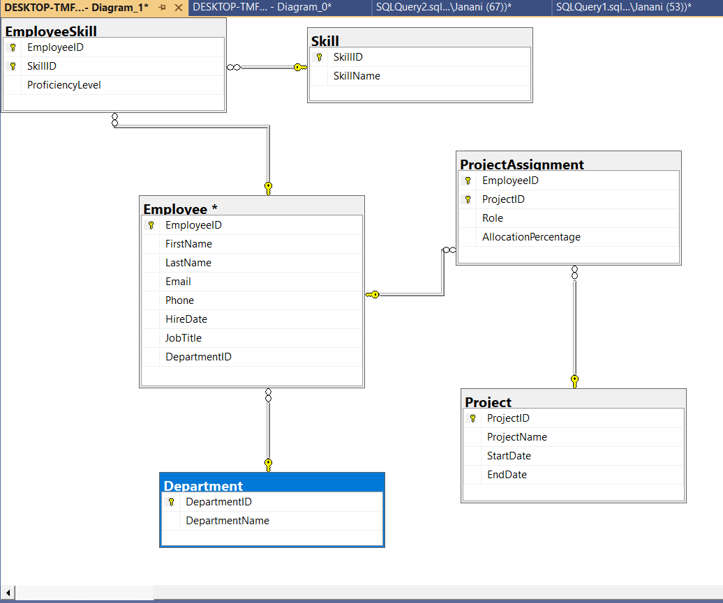

Thank you!